**Elizabeth Wachiaya – Bootstrap Portfolio Project Report**

**Plebo.com - Creating Custom City Tour Itineraries**

**Introduction**

Plebo.com will be a website that enables users to create an itinerary of places and activities while in a particular city. It acts as a personal concierge by suggesting interesting places and/or activities, then guiding the user through the set itinerary on the day of the tour. The project will initially be limited to Durham, NC locations with potential to expand to more cities.

The website will users range from Durham locals, tourists, students on field trips, etc. User research was conducted through interviewing people around Durham, and commonality among the interviewed was that they would like to explore what Durham has to offer but don’t know where to start. They want straight forward suggestions of where to visit or events happening, they need help planning these visits and guidance when completing their itinerary.

Locations and activities listed in the website will be sourced from locals who are familiar with the city’s hidden gems thereby providing visitors with unique experiences, rather than ‘tourist traps’, and in turn boosting the local economy.

**Market Survey**

Websites providing a similar service include Vistacity.com, Triphobo.com, Itineree.com, Tripomatic.com and Sygic.com. While studying these websites, it was found that while they offer adequate locations around the world, their UI is not as friendly to navigate due to the volume on information contained on a page. This could prove to be confusing to the users which may lead them to abandon the site all together. Also, majority of locations listed included tourist traps, thereby lacking in the local, personable experience.

Plebo’s UI will be clean and uncluttered. Information will be kept straight to the point with no promotions or ads on the page to distract visitors. Also, since location and activity ideas will be sourced from locals, the experience offered to visitors will be tailormade to their needs, and also feel as if they have a personal tour guide, thanks to the “Conduct Itinerary” feature.

**Navigation Structure**

The main navigation will be comprised of two options:

* Cities – Allow user to switch between different cities
  + This will present to the user a list of cities they can switch to browse city- specific locations and activities
* New Itinerary – To create an itinerary for both existing users and guests
  + Users will be presented with will get a list of locations and activities in the particular city. They can view a location’s details and add them to their itinerary from the list or detail page.
* Current Itinerary – To view the locations/activities already added to the itinerary.
  + Users will be presented with a modal which will list the locations selected, which can also be cleared.

In addition to the main navigation, users will be presented with recommendation carousels which highlight popular itineraries and locations that they can add into their own itinerary

**User Interface Design and Prototype**

The following are initial wireframes of the static content that will be developed in this project.

**Home:**

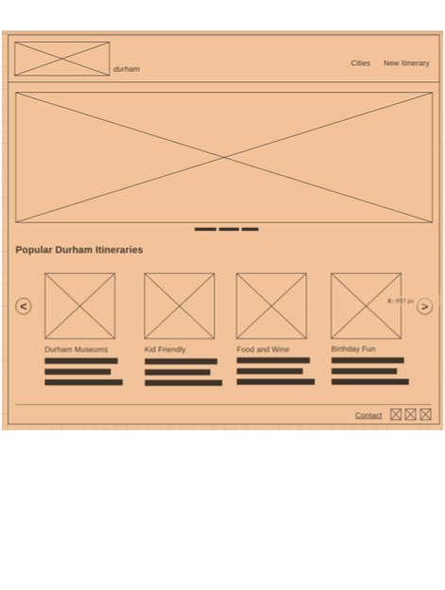

**Location and Activities List page:**

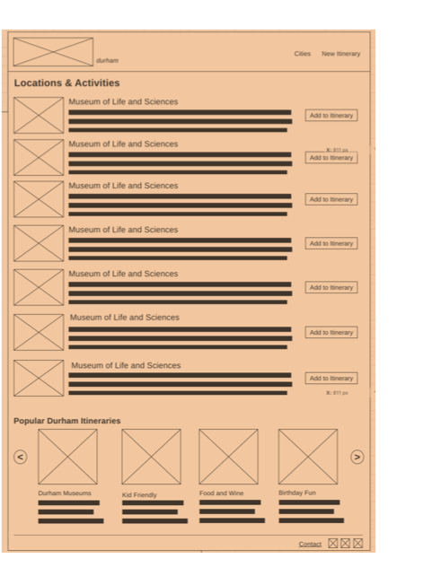

**Location Detail page:**

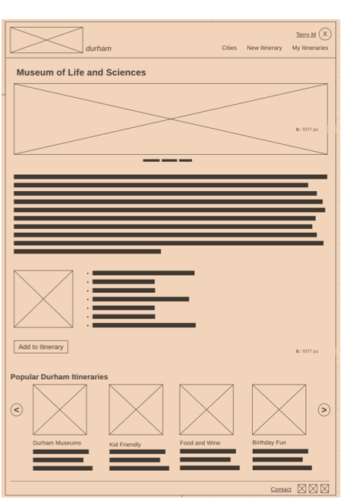

**Implementation**

The wireframes were implemented using the Bootstrap framework, and although it is currently static, the list of locations added to the itinerary is stored using the localStorage property, which allows temporary data storage and access in the browser.

Some of the bootstrap features used in this project include bootstrap grid, navigation, carousel, icons, cards, card columns, modal, together with jQuery.

A major change I made from the design was to exclude the user account features, which include managing and conducting an itinerary. This was primarily because of the lack of an API and also time constraints. This will however be included in the next phase.

The following are some screenshots of the project:

**Home**

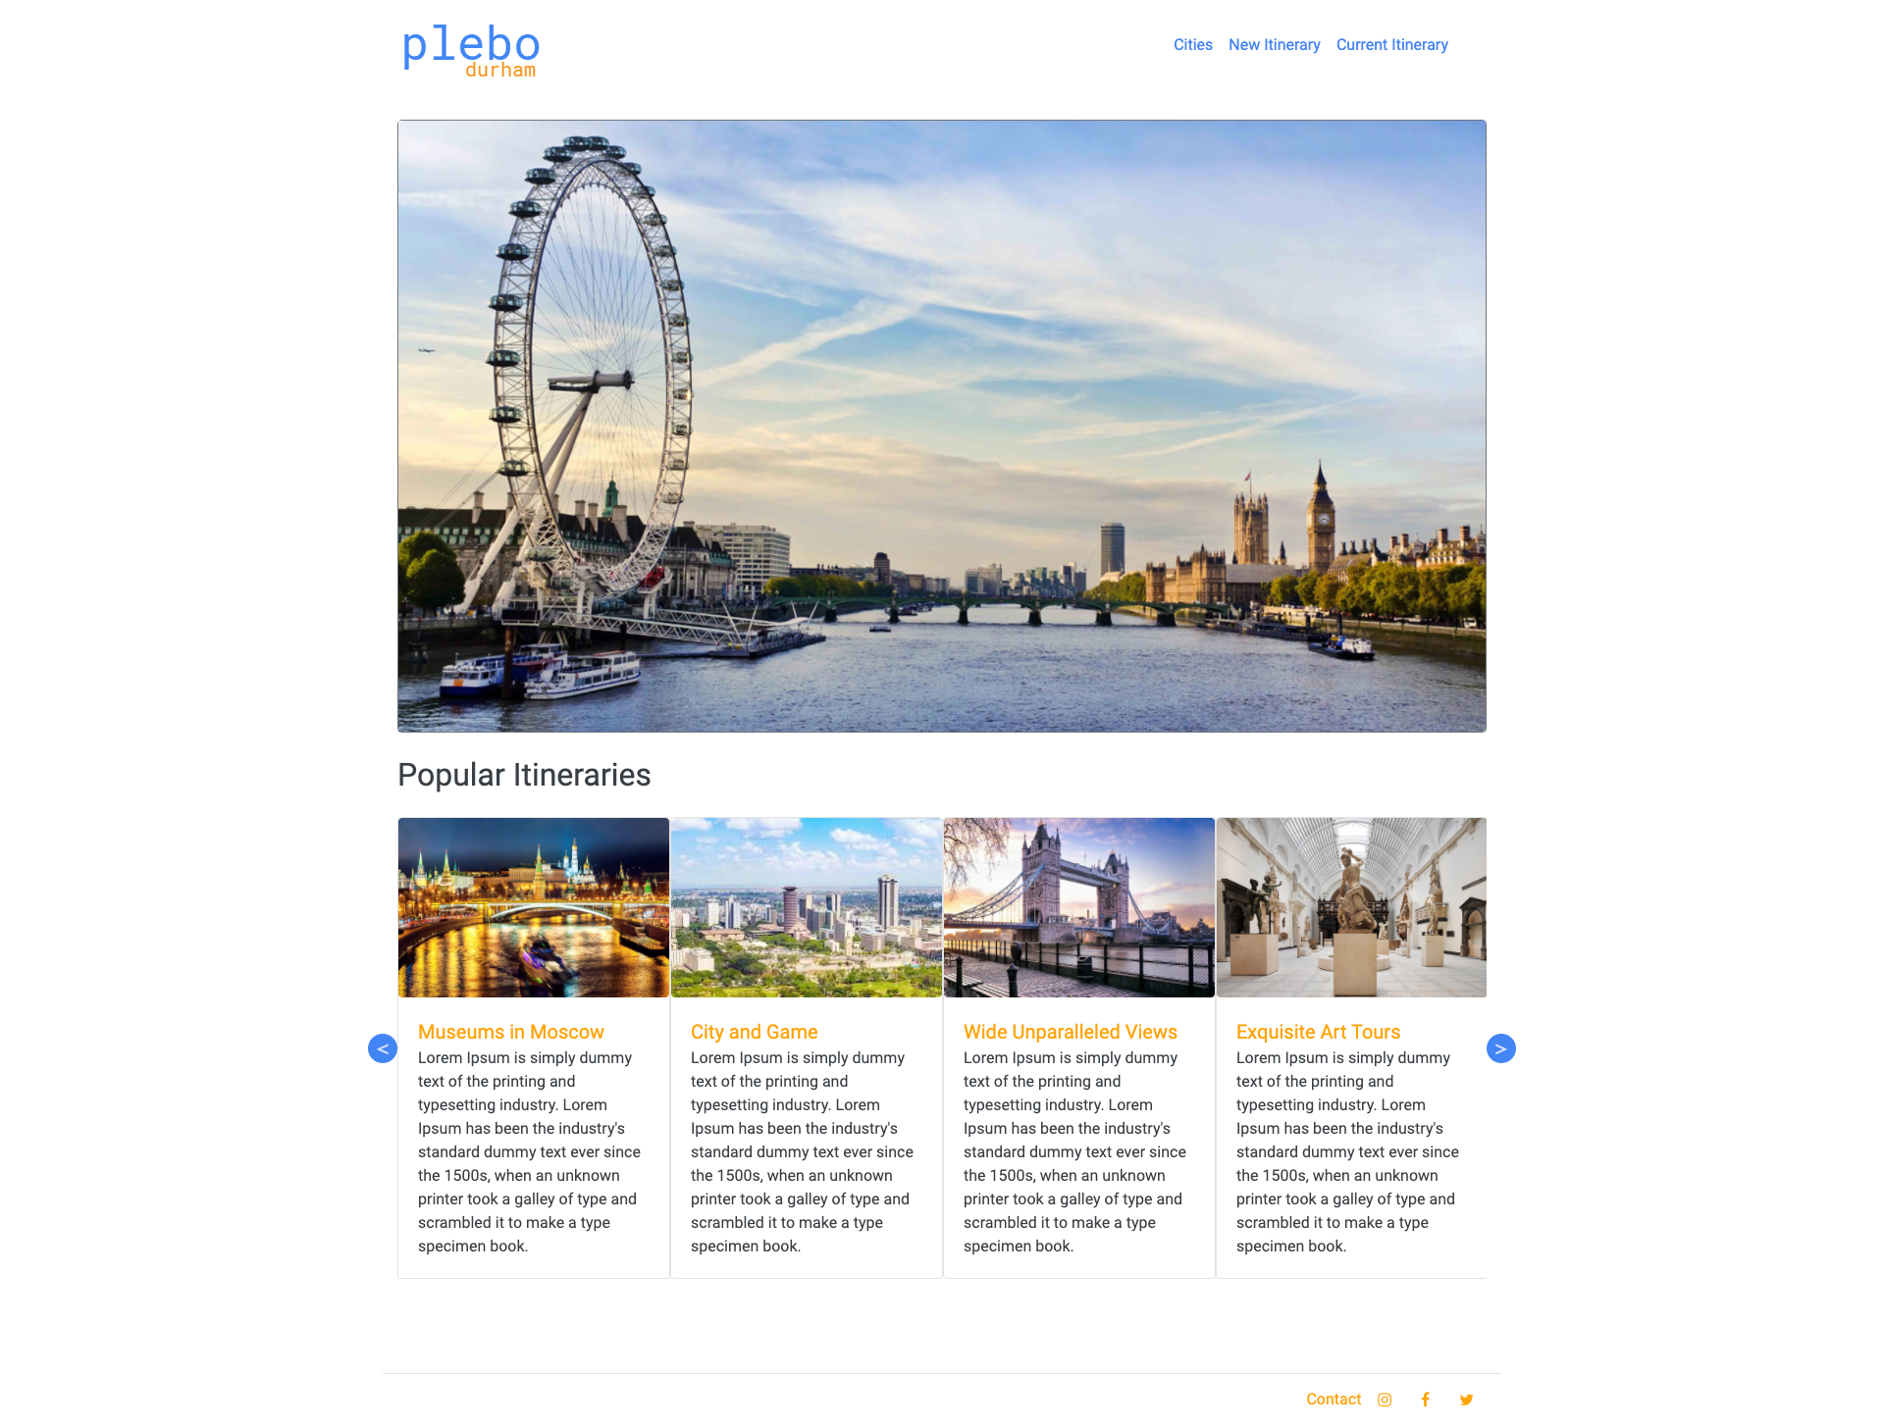

**Cities**

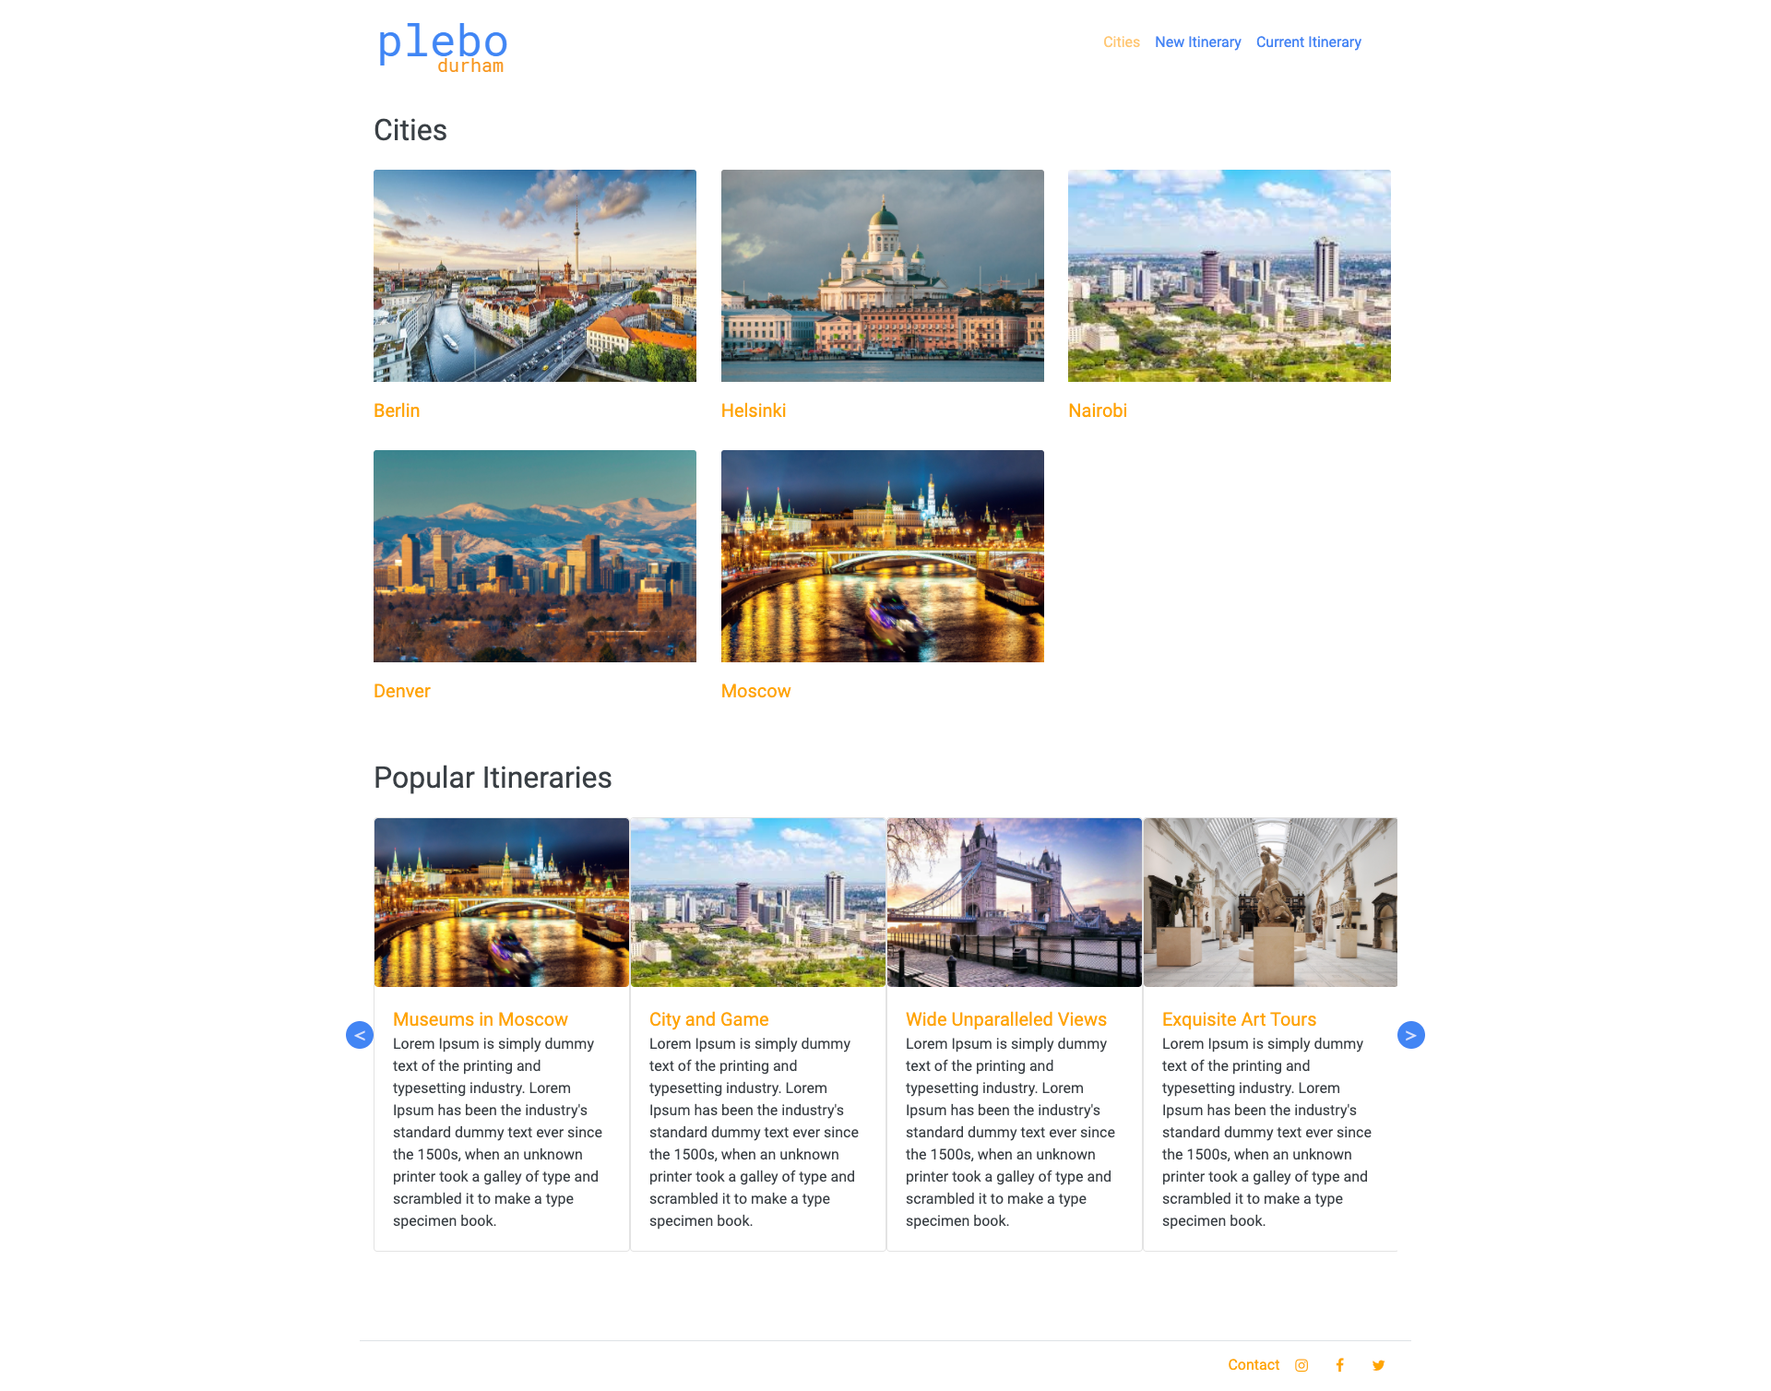

**New Itinerary**

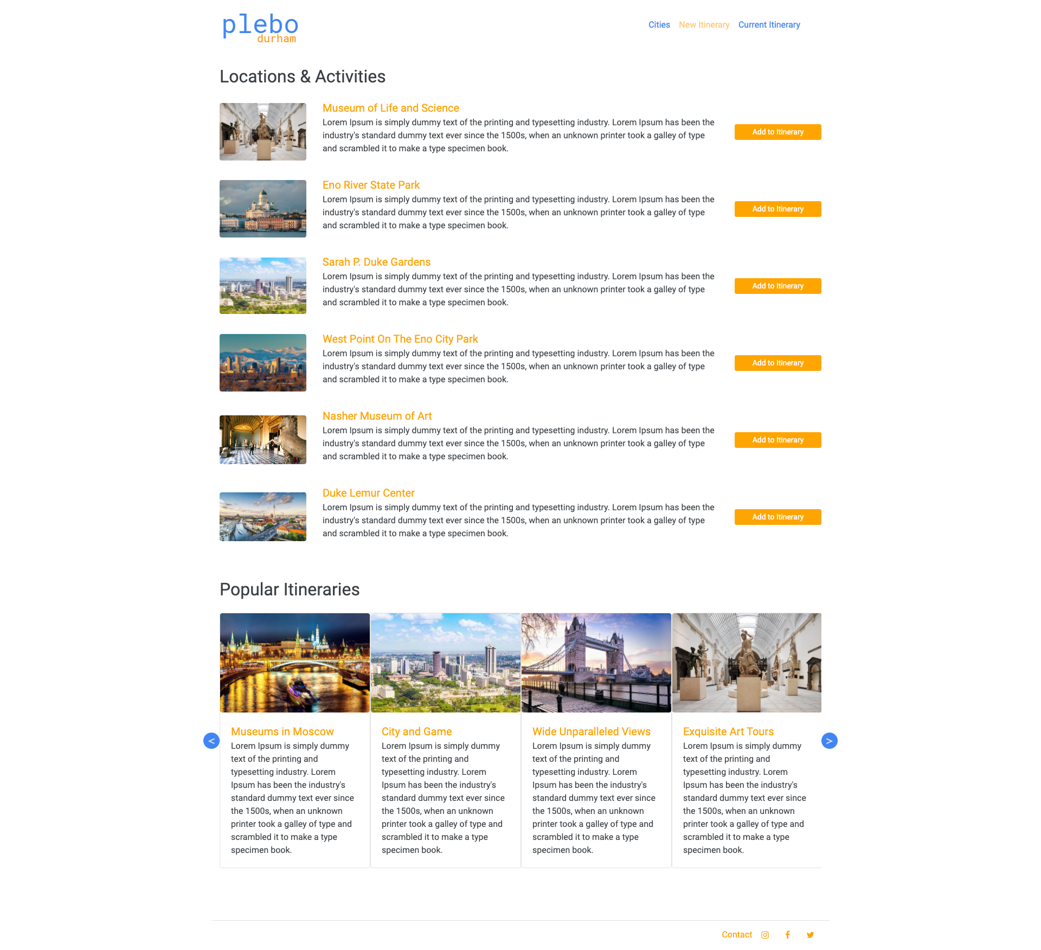

**Location Details**

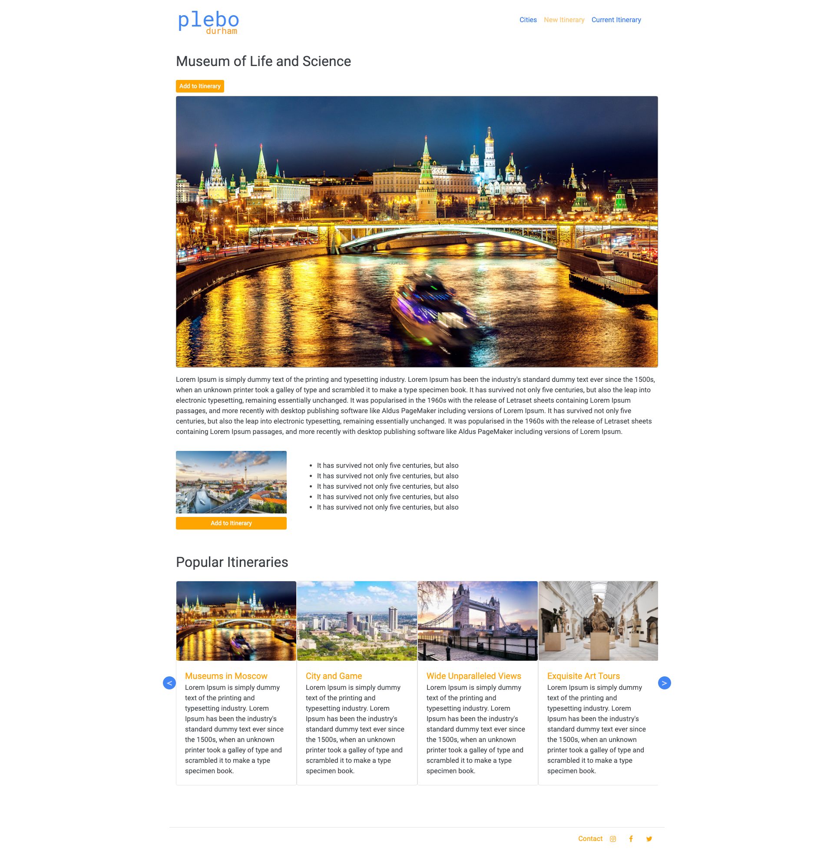

**Current Itinerary**

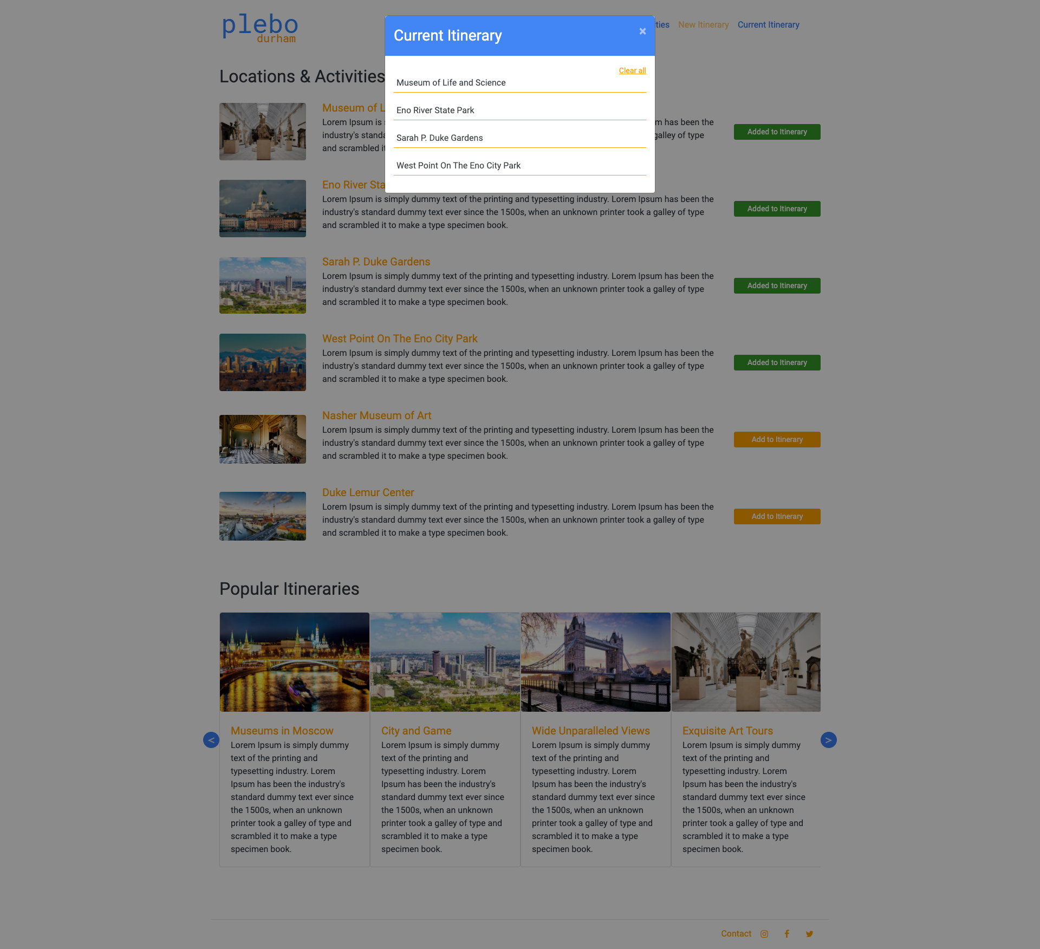

**Contact**

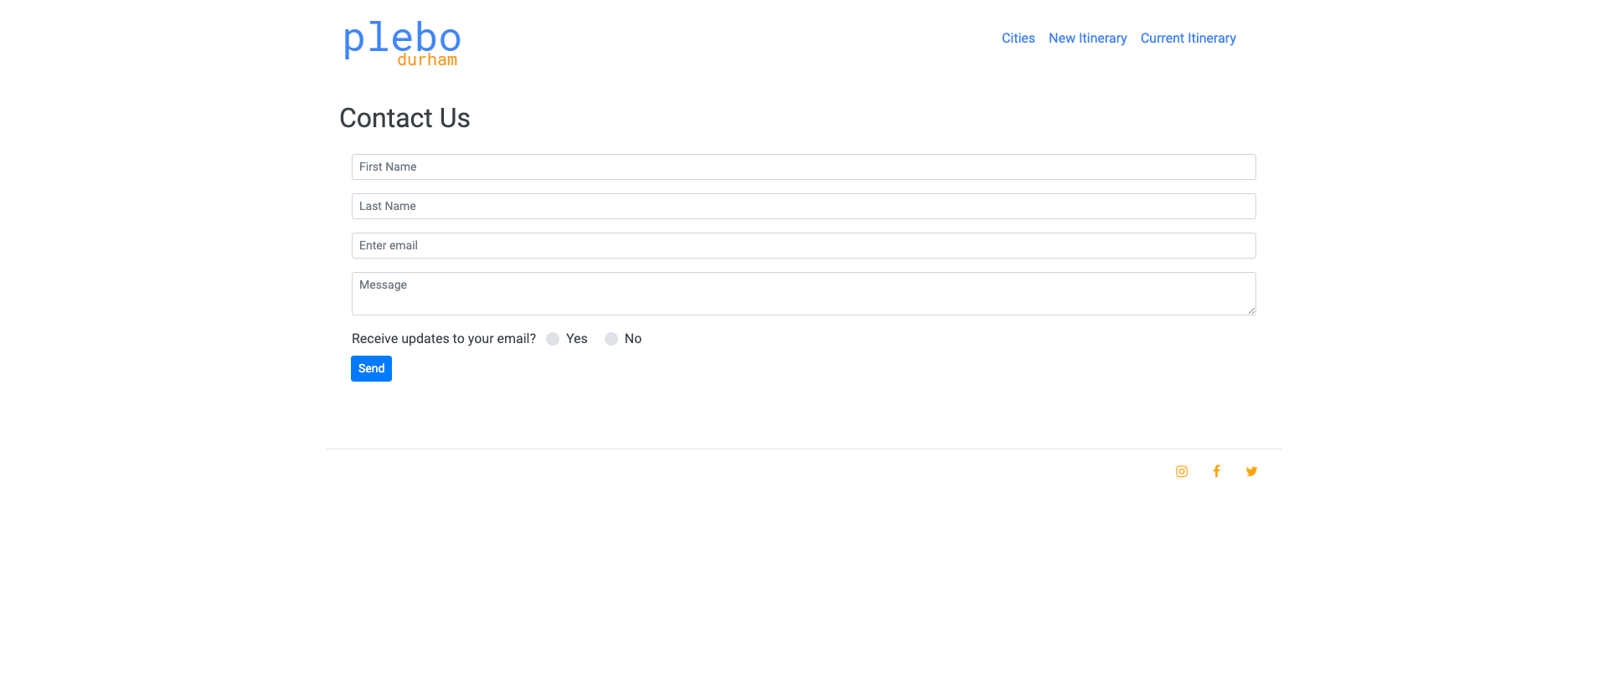

**Conclusion**

This project helped me grasp Bootstrap better and I enjoyed the journey from concept to implementation. The website has a clean interface, with only essential content, which will not confuse the user because of information overload.

Ideally content should be delivered dynamically from a data source, including, in this case, the locations, images and details. Currently the site has placeholder content, which will in future be changed to contain dynamic data. It will also be optimized to be used across different devices. Because of time constraints, dynamic features will be implemented in the next phase. I also look forward to adding features, like the ability to clear one location at a time from the itinerary, as opposed to clearing all of them, and also the ability for user to create accounts to better manage their itineraries.

All in all, it was an exciting and enriching project to work on in a short time.

**References**

1. VisitACity:CreateYourPersonalTravelGuide.(n.d.).RetrievedApril16,2020, from https://www.visitacity.com/
2. VacationPlannerforYourHolidays:TripHobo.RetrievedApril16,2020,from https://www.triphobo.com/
3. Travel Itinerary Planner: Itineree. Retrieved April 16, 2020, from http://itineree.com//
4. ItineraryManagementforTravelProfessionals:Travefy.RetrievedApril16,2020, from https://travefy.com/
5. TravelPlannerandItineraryMaker:SygicTravel.RetrievedApril16,2020,from https://travel.sygic.com/
6. The Go-to Wireframing Tool: Wireframe.cc. Retrieved April 20, 2020, from https://wireframe.cc/